- Follow the APA samples below for designing your tables and figures. Notice that the use of borders or lines in a table is limited. DO NOT use vertical and horizontal lines to separate the data, or around every cell in a table.
- Font size should not be smaller than 10 or bigger than 12 and should be consistent in all figures and tables.
- Tables and figures should appear after the end of a paragraph (centered) when referred to for the first time (embedded within the text). Your description or commentary should be written as close as possible to the figure or table, separated by one 1.5 blank line. Additional descriptions can be written below the table or figure.
- Refer to every table and figure by its number, not with “the table above’ or “below” (APA, 2020).
- A reprinted or adapted table or figure from another source must have a copyright attribution in the table note or figure note to cite the origin of the material. A corresponding reference entry must be made in the Reference section.
- Tables or figures that are wide may be displayed in landscape orientation. For tables longer than one page, copy the heading row on the next page/s of the table.

Some samples included in the APA Publication Manual (7th ed.) are shown in the next pages. Follow the formatting style of tables and figures. The table and figure components are clearly labeled.

Sample 1
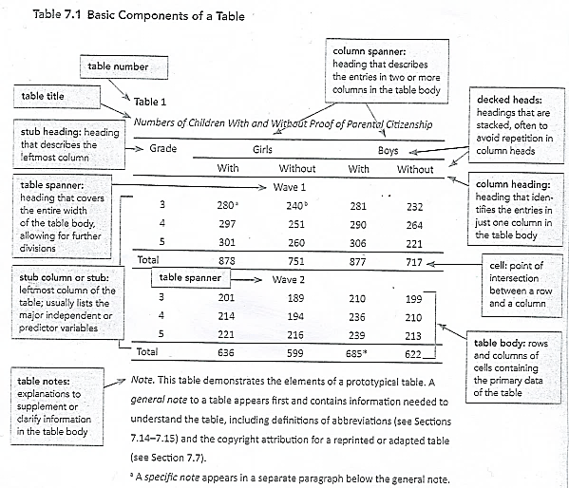

Sample 2
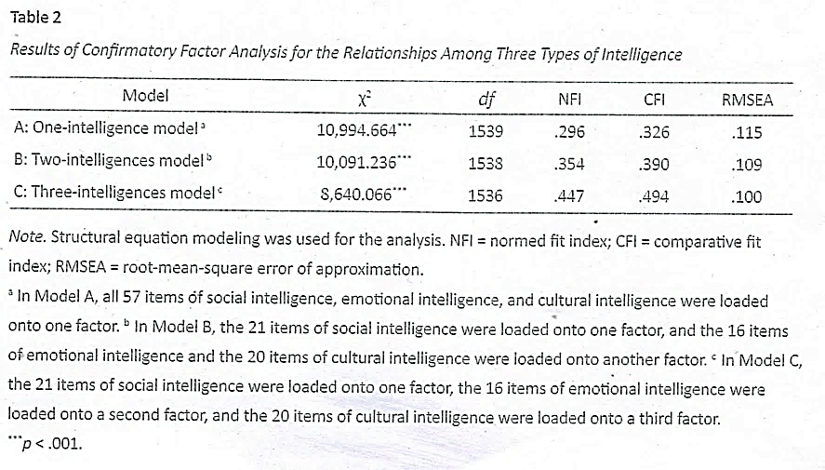
Sample 3 Qualitative Table with Variable Descriptions

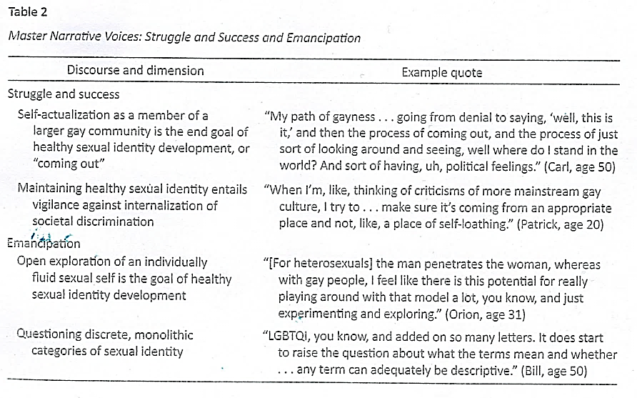

Sample 4 Figure/Table with Copyright Attribution (added in the Note.)
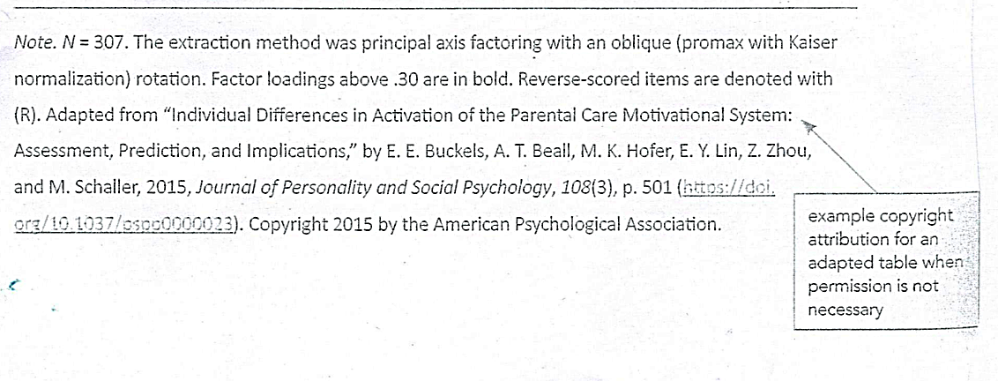
Note. Sample 4 is incorporated in Section 7 of the APA Publication Manual (7th ed.). For copyright attribution or reference to the original source of the material, a complete reference is made in the Note and in the Reference section.

Sample 5
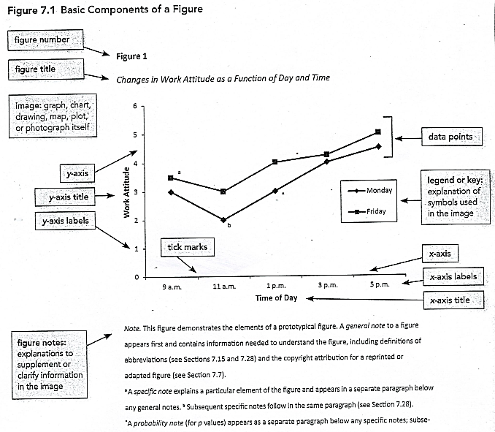

Sample 6
